Meersbrook Bank Primary School
Derbyshire Lane, Sheffield, S8 9EH

Tel: 0114 2814423 | enquiries@meersbrookbank.sheffield.sch.uk  www.meersbrookbank.sheffield.sch.uk
Head Teacher: Mrs G. Harvey
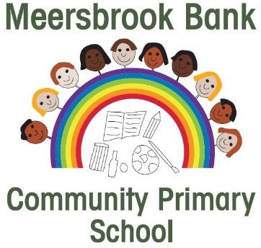
PUPIL PREMIUM APPLICATION FORM
Child 1’s Name |  |  |  |  |  |  | Child 1’s  Date Of Birth
Child 2’s Name |  |  |  |  |  |  | Child 2’s  Date Of Birth
Child 3’s Name |  |  |  |  |  |  |  | Child 3’s  Date Of Birth
Parent / Carer 1
Full name of parent / carer
Date of Birth |  | National Insurance or NASS number
Daytime phone number
Parent / Carer 2
Full name of parent / carer
Date of Birth |  | National Insurance or NASS number
Daytime phone number
Is the joint household annual income over £16,190 per year? |  |  | Yes No Don’t know
Is either parent in receipt of any of the benefits listed below: |  |  | Yes No Don’t know
- Income Support
- Income-based Jobseekers Allowance
- Income-related Employment and Support Allowance
- Support from NASS (National Asylum Support Service) under part 6 of the Immigration and Asylum Act 1991
- The guarantee element of State Pension Credit
- Child Tax Credit (with no Working Tax Credit with an annual income of no more than £16,190)
- Working Tax Credit run-on (paid for 4 weeks after you stop qualifying for Working Tax Credit)
- Universal Credit

Is your child adopted? |  |  | Yes No
Has your child ever been looked after by the local authority for more than one day? |  |  | Yes No
Has your child ever been subject to a special guardianship or child arrangement (residence) order? |  |  | Yes No
DECLARATION
The information I have given on this form is complete and accurate, I understand that my personal information is held securely and will be used only for Local Authority purposes. I agree to the Local Authority using this information to process my application for pupil premium and/or free school meals. I also agree to notify the local authority in writing of any change in my family’s financial circumstances as set out in this form.
Print
Signature |  | Date
Thank you for taking the time to complete this form. Providing this information could raise an extra £1,320 for the school, to fund valuable support for your child such as extra tuition, trips, additional teaching staff or after school activities. This additional money is available from central government for every eligible child. For further information, contact Sheffield City Council Tel: 0114 2734567 or www.sheffield.gov.uk

